|  |  |  |  |
| --- | --- | --- | --- |
| **Name of Project : College Complaint Portal** | | | |
| **Sr.No** | **Name of students** | **Roll No** | **Contribution of Each participants** |
| 1 | Harkirat Chauhan | N210 | **Admin page** **after logging** using html and css for structure and styling, php to fetch complaints from database. |
| 2 | Dhara Dhakad | N214 | **Complaint form page**, Successful registration page using html and css for designing form and styling, JavaScript for form validation, php for connecting complaint form details to the register table in database. |
| 3 | Natasha Doshi | N216 | **Admin Login page, Student Login page** using html and css for structure and styling, JavaScript for form validation, php to connect login info to the database. |
| 4 | Ritika Goswami | N221 | **Home page** using html and css for structure and styling, JavaScript for slideshow of images, php and sql to make connection database to the website. |

**Description of website:**

|  |  |
| --- | --- |
| **Number of web pages in your project** | **6**  (complaintportal.php, complaintform.php, a_login.php, s_login.php, insert.php, a_posts.php) |
| **Number actively working link in your project** | **21** |
| **Number of Column in database** | **Admin-3**  **Register-8**  **Student-4** |

**Introduction:**

Students face numerous problems in their hostels like furniture, electricity or plumbing issues. Thus, the basic idea behind this website was to provide a platform for students to make it easy for them to register their complaints, to pay attention to the issues the students face and to solve them as soon as possible.

The website is the **College Complaint Portal**. The homepage consists of a slideshow of images, information about the portal and NMIMS Shirpur. It has the contact information i.e address, phone number and links to the different social medias of the college. It contains a navigation bar too for switching from page to page.

It then has the complaint form where the students can register the problems they’re facing in their hostels. Students who have been registered in the database of the college will be the only ones able to register. This has been done to prevent false registrations.

It also contains the admin login page where the admin can log in and check all the complaints that have been registered by the students. And once the admin is done then they can logout and return to the homepage of the site.

**SCREENSHOTS:**

1. **COMPLAINPORTAL.PHP:**

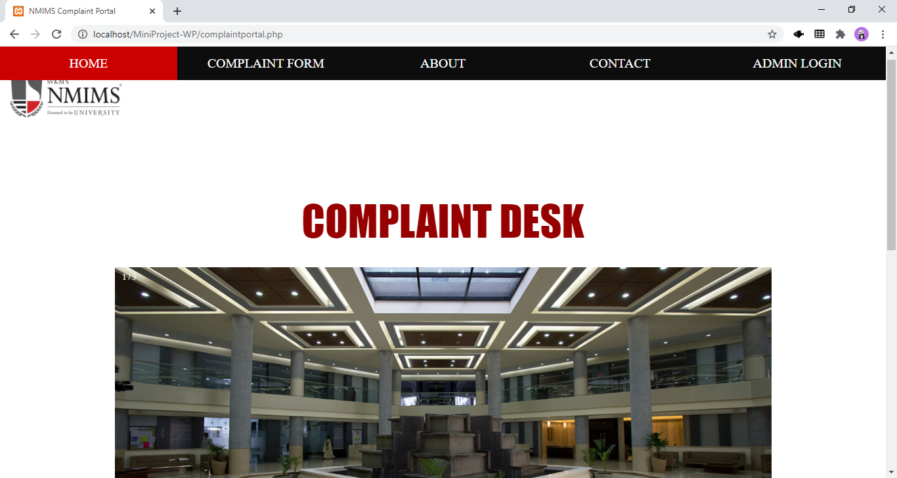

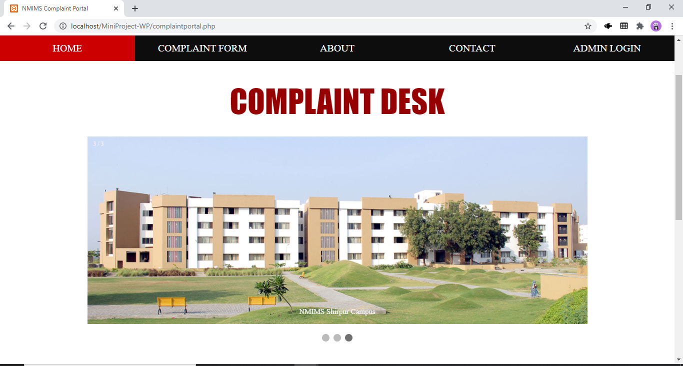

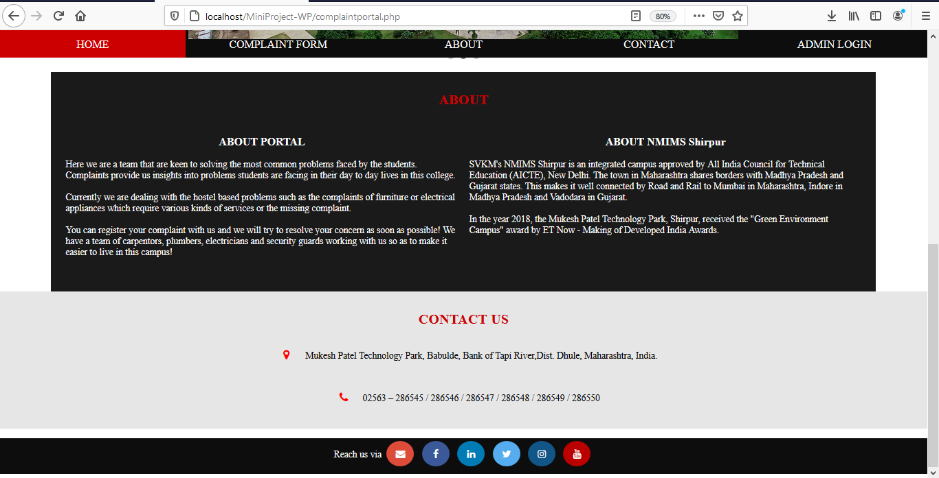

1. On clicking Complaint Form, we are redirected to a page for student login **(S_LOGIN.PHP):**

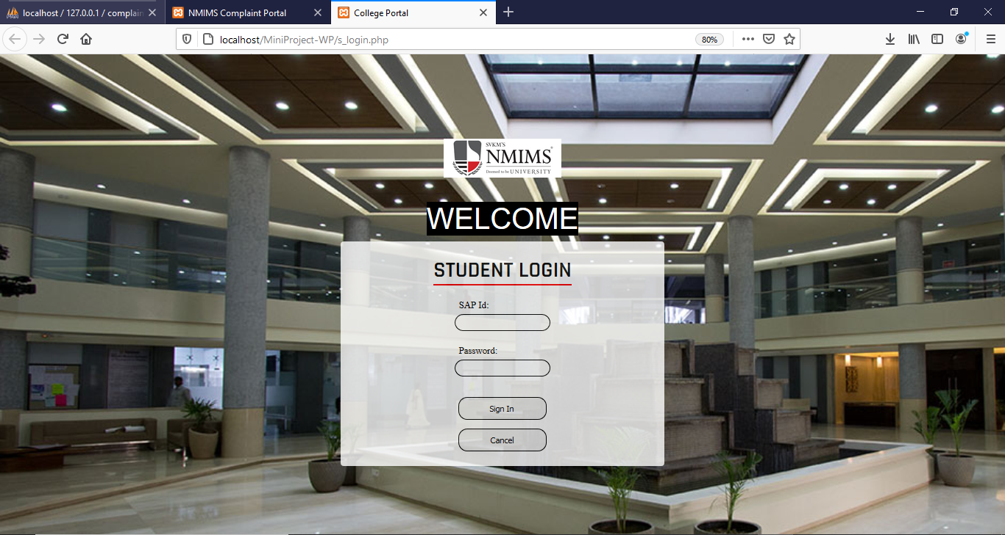

1. Upon successful login, we are redirected to the complaint form for registering complaints **(COMPLAINTFORM.PHP)**:

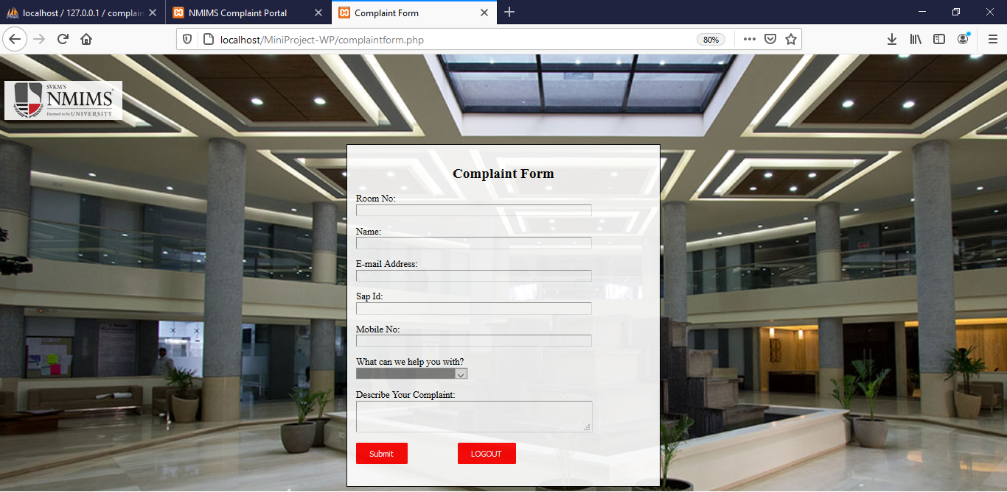

1. After registration of complaint is successful, we are redirected to another page which tells us that we have successfully registered the complaint **(INSERT.PHP)**:

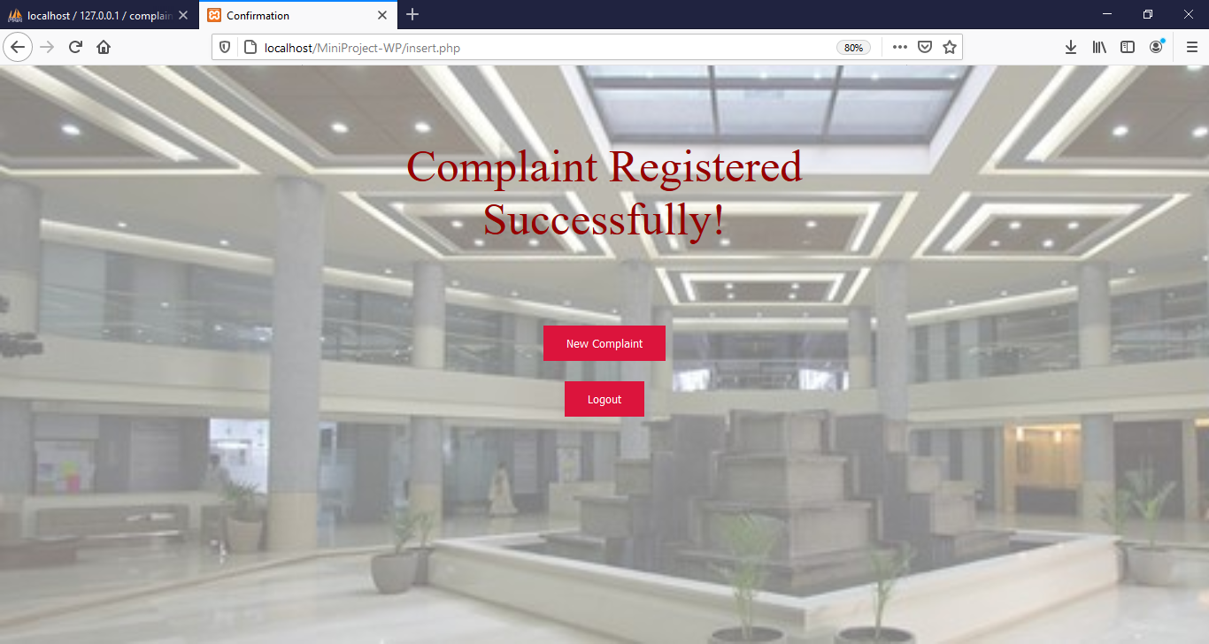

1. Now, we have an admin login **(A_LOGIN)**:

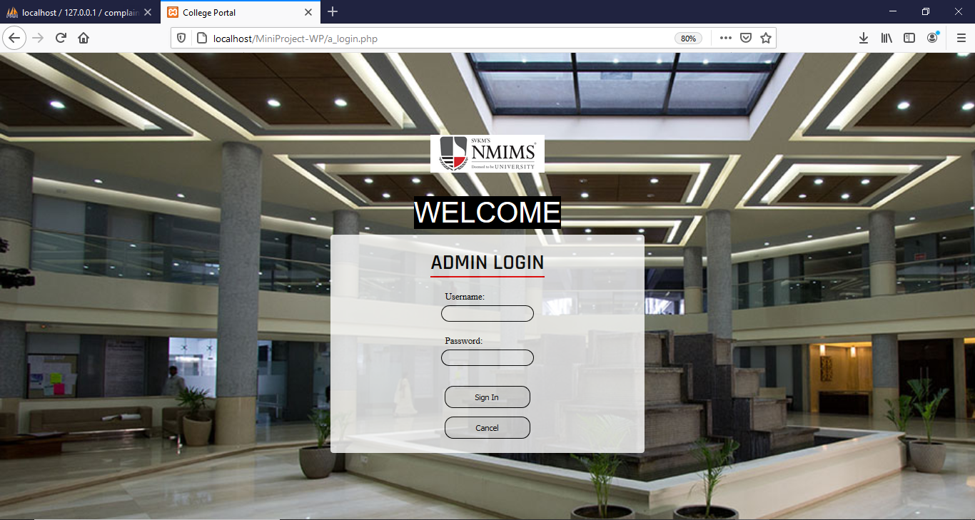

1. Upon successful login, we are redirected to a page which contains all complaints**(A_POSTS.PHP)**:

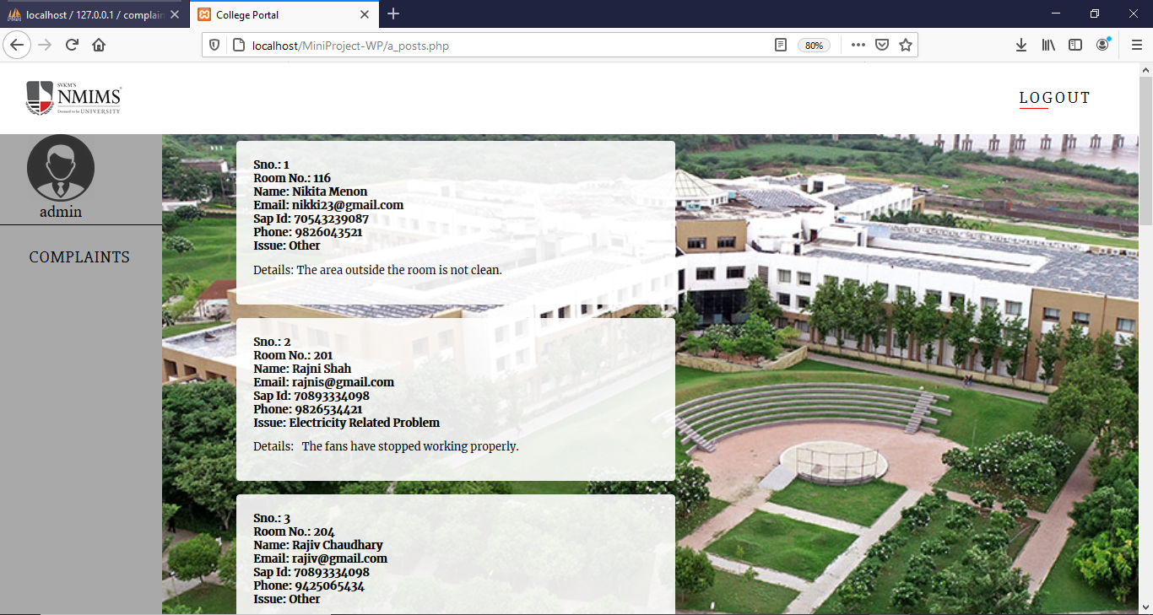

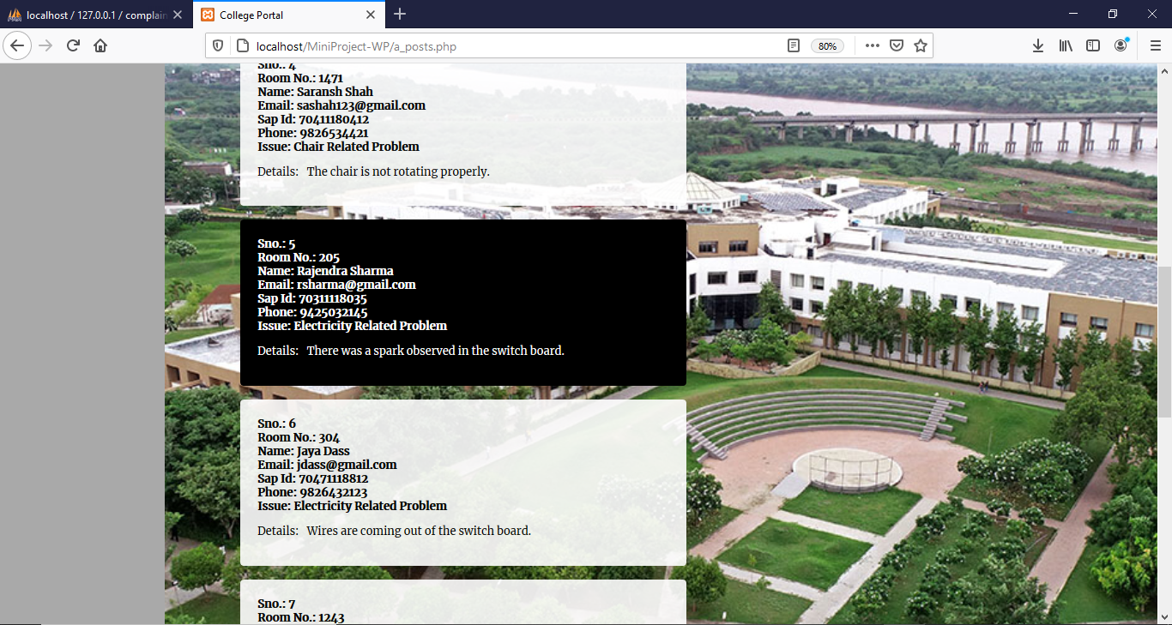

1. The database **COMPLAIN_PORTAL** contains 3 tables:

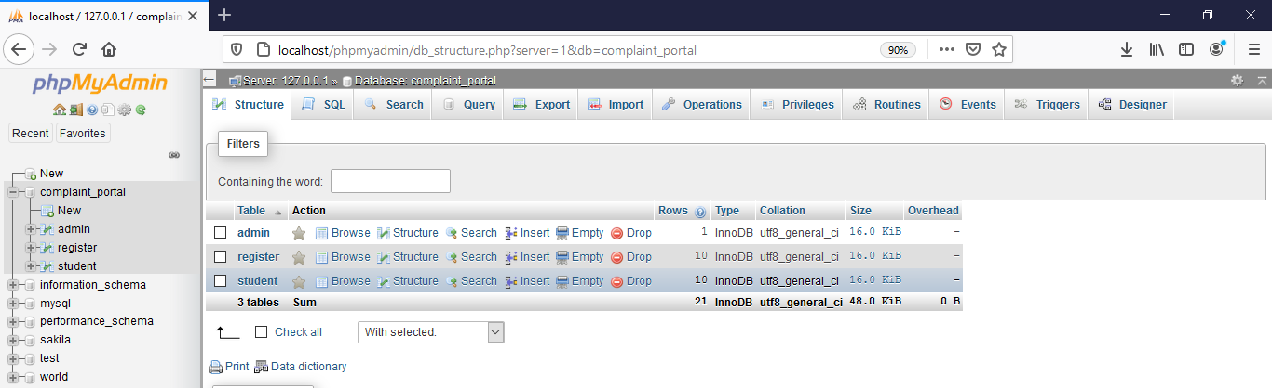

1. Admin

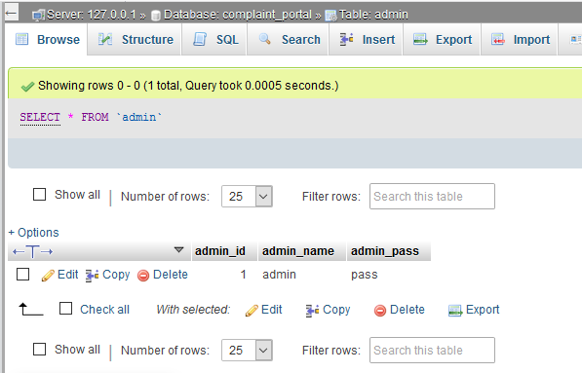

1. Register

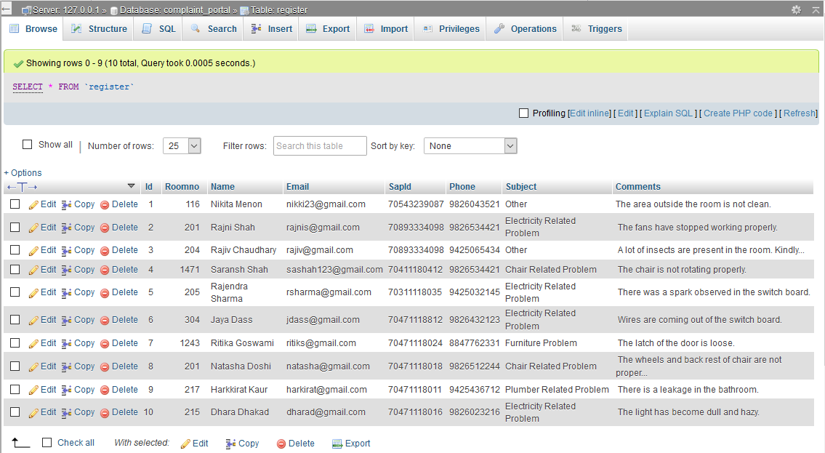

1. Student

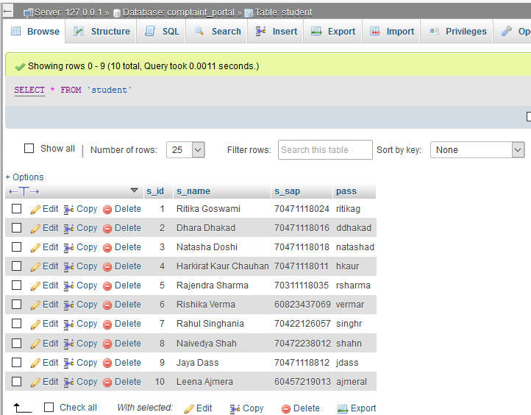

**CODES:**

1. **complaintportal.php:**

<!DOCTYPE html>

<html lang="en">

<head>

<title> NMIMS Complaint Portal</title>

<meta charset="UTF-8" />

<meta name="viewport" content= "width=device-width, initial-scale=1.0" />

<link rel="stylesheet" href="style.css" />

<link rel="stylesheet" href="https://cdnjs.cloudflare.com/ajax/libs/font-awesome/4.7.0/css/font-awesome.min.css">

</head>

<body>

<script>

function myFunction() {

var x = document.getElementById("myTopnav");

if (x.className === "topnav") {

x.className += " responsive";

}

else {

x.className = "topnav";

}

}

</script>

<nav class="topnav">

<a class="active" href="#logo">HOME</a>

<a href="s_login.php" target="new">COMPLAINT FORM</a>

<a href="#about">ABOUT</a>

<a href="#contact">CONTACT</a>

<a href="a_login.php" target="new">ADMIN LOGIN</a>

</nav>

<div class="logo" id="logo">

<a href="https://www.nmims.edu/">

<img src=img/logo.png alt="nmims" style="height: 170px; width: 200px; object-fit: contain; padding: 0px;">

</a>

</div>

<div class="heading" id="home">

<p>COMPLAINT DESK</p>

</div><br><br><br><br>

<div class="slideshow-container">

<!-- Full-width images with number and caption text -->

<div class="mySlides fade">

<div class="numbertext">1 / 3</div>

<img src="img/shirpur4.jpg" style="width:100%">

<div class="text">NMIMS Shirpur Campus</div>

</div>

<div class="mySlides fade">

<div class="numbertext">2 / 3</div>

<img src="img/shirpur2.jpg" style="width:100%">

<div class="text">NMIMS Shirpur Campus</div>

</div>

<div class="mySlides fade">

<div class="numbertext">3 / 3</div>

<img src="img/shirpur1.jpg" style="width:100%">

<div class="text">NMIMS Shirpur Campus</div>

</div>

</div>

<br>

<!-- The dots/circles -->

<div style="text-align:center">

<span class="dot"></span>

<span class="dot"></span>

<span class="dot"></span>

</div>

<script type="text/javascript">

var slideIndex = 0;

showSlides();

function showSlides() {

var i;

var slides = document.getElementsByClassName("mySlides");

var dots = document.getElementsByClassName("dot");

for (i = 0; i < slides.length; i++) {

slides[i].style.display = "none";

}

slideIndex++;

if (slideIndex > slides.length) {slideIndex = 1}

for (i = 0; i < dots.length; i++) {

dots[i].className = dots[i].className.replace(" active", "");

}

slides[slideIndex-1].style.display = "block";

dots[slideIndex-1].className += " active";

setTimeout(showSlides, 2000); // Change image every 2 seconds

}

</script>

<br>

<div class="about" id="about">

<h2 style="color: #cc0000; text-align: center;">ABOUT</h2>

<div class="aboutp">

<h3 style="text-align: center;">ABOUT PORTAL</h3>

<p>

Here we are a team that are keen to solving the most common problems faced by the students.<br>

Complaints provide us insights into problems students are facing in their day to day lives in this college.<br><br>

Currently we are dealing with the hostel based problems such as the complaints of furniture or electrical appliances which require various kinds of services or the missing complaint.<br><br>

You can register your complaint with us and we will try to resolve your concern as soon as possible! We have a team of carpentors, plumbers, electricians and security guards working with us so as to make it easier to live in this campus!<br>

</p>

</div>

<div class="aboutp">

<h3 style="text-align: center;">ABOUT NMIMS Shirpur</h3>

<p>

SVKM's NMIMS Shirpur is an integrated campus approved by All India Council for Technical Education (AICTE), New Delhi. The town in Maharashtra shares borders with Madhya Pradesh and Gujarat states. This makes it well connected by Road and Rail to Mumbai in Maharashtra, Indore in Madhya Pradesh and Vadodara in Gujarat.<br><br>

In the year 2018, the Mukesh Patel Technology Park, Shirpur, received the "Green Environment Campus" award by ET Now - Making of Developed India Awards.

</p>

</div>

</div>

<div class="contact" id="contact">

<h2 style="color: #cc0000; text-align: center;">CONTACT US</h2>

<p>

<i class="fa fa-map-marker" style="font-size:20px;color:red"></i>

Mukesh Patel Technology Park, Babulde, Bank of Tapi River,Dist. Dhule, Maharashtra, India.

</p>

<p>

<i class="fa fa-phone" style="font-size:20px;color:red"></i>

02563 – 286545 / 286546 / 286547 / 286548 / 286549 / 286550

</p>

</div>

<div class="reach id="reach">

<p>Reach us via

<a href="mailto:complaintportal@example.com" style="font-style: bold;"><i class="fa fa-envelope"></i></a>

<a href="https://www.facebook.com/NMIMS.India" target="_blank" class="facebook-bg"><i class="fa fa-facebook"></i></a>

<a href="https://www.linkedin.com/school/nmims_india/" target="_blank" class="linkedin-bg"><i class="fa fa-linkedin"></i></a>

<a href="https://twitter.com/nmims_india" target="_blank" class="twitter-bg"><i class="fa fa-twitter"></i></a>

<a href="https://www.instagram.com/nmims_india/" target="_blank" class="instagram-bg"><i class="fa fa-instagram"></i></a>

<a href="https://www.youtube.com/user/nmimsedu" target="_blank" class="youtube-bg"><i class="fa fa-youtube"></i></a>

</p>

</div>

1. **s_login.php:**

<?php

session_start();

if ( isset($_SESSION['id']) ) {

header("Location: s_login.php ");

}

?>

<!DOCTYPE html>

<html lang="en">

<head>

<meta charset="UTF-8">

<meta name="viewport" content="width=device-width, initial-scale=1.0">

<meta http-equiv="X-UA-Compatible" content="ie=edge">

<title>College Portal</title>

<link rel="stylesheet" href="./main.css">

<link href="https://fonts.googleapis.com/css?family=Lobster&display=swap" rel="stylesheet">

<link href="https://fonts.googleapis.com/css?family=Rajdhani:600&display=swap" rel="stylesheet">

</head>

<body>

<div class="logo" id="logo">

<a href="https://www.nmims.edu/">

<img src=img/logo.png alt="nmims" style="height: 140px; width: 200px; object-fit: contain; padding: 0px;">

</a>

</div>

<div class="welcome">

WELCOME

</div>

<form action="login2.php" class="container" method="POST">

<p style="font-family: 'Rajdhani', sans-serif; font-size: 10mm; margin:0px">STUDENT LOGIN</p>

<?php

if(isset($_REQUEST['activity'])){

if($_REQUEST["activity"] == "error"){

?>

<div style="display: flex; padding: 20px; flex-direction:column">

<label style='color:red;'>Username and Password didn't match</label>

</div>

<?php

}

if($_REQUEST["activity"] == "loggedout"){

?>

<div style="display: flex; padding: 20px; flex-direction:column">

<label style='color:green;'>You are successfully logged out.</label>

</div>

<?php

}

if($_REQUEST["activity"] == "expired"){

?>

<div style="display: flex; padding: 20px; flex-direction:column">

<label style='color:green;'>You session is expired. Login again</label>

</div>

<?php

}

}

?>

<div style="display: flex; padding: 20px; flex-direction:column">

<label>SAP Id:</label>

<input type="text" name="a_user" class="input" required>

</div>

<div style="display:flex; padding: 20px; padding-top: 0px; flex-direction:column">

<label>Password:</label>

<input type="password" name="a_pwd" class="input" required>

</div>

<button class="btn" type="submit">Sign In</button>

<a href="complaintportal.php">

<input type="button" class="btn" value="Cancel">

</a>

</form>

</body>

</html>

1. **login2.php: (for s_login)**

<?php

define('DB_USER', "root"); // db user

define('DB_PASSWORD', "123456"); // db password (mention your db password here)

define('DB_DATABASE', "Complaint_portal"); // database name

define('DB_SERVER', "127.0.0.1"); // db server

$conn = mysqli_connect(DB_SERVER,DB_USER,DB_PASSWORD,DB_DATABASE) or die("unable to connect");

if ( isset($_POST['a_user']) && isset($_POST['a_pwd']) ) {

$entered_username = $_POST['a_user'];

$entered_password = $_POST['a_pwd'];

$sql = "SELECT * FROM student WHERE s_sap = '$entered_username' AND pass ='$entered_password'";

$result = mysqli_query($conn, $sql);

$res = mysqli_fetch_array($result);

if(mysqli_num_rows($result) > 0) {

session_start();

$_SESSION['uname'] = $res['s_sap'];

$_SESSION['id'] = $res['s_id'];

header("Location: complaintform.php");

}

else {

header("location:a_login.php?activity=error");

}

}

?>

1. **logout.php:**

<?php

session_start();

session_destroy();

header("location:complaintportal.php");

?>

1. **complaintform.php:**

<html>

<head>

<title>Complaint Form</title>

<link rel="stylesheet" href="formstyle.css" />

</head>

<body>

<script>

function ValidateContactForm()

{

var name = document.ContactForm.Name;

var email = document.ContactForm.Email;

var phone = document.ContactForm.Telephone;

var nocall = document.ContactForm.DoNotCall;

var what = document.ContactForm.Subject;

var comment = document.ContactForm.Comment;

var rno = document.ContactForm.RoomNo;

var sid = document.ContactForm.SapId;

var submit=document.ContactForm.submit;

if (name.value == "")

{

window.alert("Please enter your name.");

name.focus();

return false;

}

if (what.selectedIndex < 1)

{

alert("Please tell us how we can help you.");

what.focus();

return false;

}

if (email.value == "")

{

window.alert("Please enter a valid e-mail address.");

email.focus();

return false;

}

if (email.value.indexOf("@", 0) < 0)

{

window.alert("Please enter a valid e-mail address.");

email.focus();

return false;

}

if (email.value.indexOf(".", 0) < 0)

{

window.alert("Please enter a valid e-mail address.");

email.focus();

return false;

}

if (isNaN(rno.value))

{

window.alert("Please enter numeric values only.");

return false;

}

if (rno.value.length>4 || rno.value=="" || rno.value<=0)

{

window.alert("Please enter valid Room No");

return false;

}

if (isNaN(sid.value))

{

window.alert("Please enter numeric values only.");

return false;

}

if (sid.value.length!=11 || sid.value=="" || sid.value<=0)

{

window.alert("Please enter valid SapId");

return false;

}

if(isNaN(phone.value) || phone.value.length!=10)

{

window.alert("Please enter valid mobile no ");

return false;

}

if(comment.value.trim().length<=10)

{

window.alert("Minimum 10 words required");

return false;

}

if (true) {

window.alert("Your Complaint have been registered");

}

}

</script>

<div class="logo" id="logo">

<a href="https://www.nmims.edu/">

<img src=img/logo.png alt="nmims" style="height: 140px; width: 200px; object-fit: contain; padding: 0px;">

</a>

</div>

<div class="d1" id="d1">

<h2 style="text-align: center;">Complaint Form</h2>

<form action = "insert.php" method="POST" name="ContactForm" onSubmit="return ValidateContactForm()">

<p>Room No: <br><input type="text" size="50" name="RoomNo"></p>

<p>Name: <br><input type="text" size="50" name="Name"></p>

<p>E-mail Address: <br> <input type="text" size="50" name="Email"></p>

<p>Sap Id: <br><input type="text" size="50" name="SapId"></p>

<p>Mobile No:<br> <input type="text" size="50" name="Telephone"><br>

<p>What can we help you with?<br>

<select type="text" value="" name="Subject" style="background-color: grey;">

<option> </option>

<option>Furniture Problem</option>

<option>Chair Related Problem</option>

<option>Electricity Related Problem</option>

<option>Plumber Related Problem</option>

<option>Other</option>

</select></p>

<p>Describe Your Complaint:<br> <abbr><textarea cols="50" name="Comment"> </textarea></abbr></p>

<p><input type="submit" value="Submit" name="submit" id="sub" class="sub">

&nbsp&nbsp&nbsp&nbsp&nbsp&nbsp&nbsp&nbsp&nbsp

&nbsp&nbsp&nbsp&nbsp&nbsp&nbsp&nbsp&nbsp&nbsp

<a href="logout.php"><button type="button" class="sub">LOGOUT</button></a></p>

</form>

</div>

</body>

</html>

1. **insert.php:**

<head>

<title>Confirmation</title>

<style type="text/css">

body{

height=100%;

}

.bg {

background-image:url(img/shirpur5.jpg);

background-repeat:no-repeat;

background-size:cover;

height: 100%;

}

.button {

background-color:crimson;

border: none;

color: white;

padding: 15px 32px;

text-align: center;

text-decoration: none;

display: inline-block;

font-size: 16px;

margin: 4px 2px;

cursor: pointer;

}

</style>

<meta charset="UTF-8" />

<meta name="viewport" content= "width=device-width, initial-scale=1.0" />

<link rel="stylesheet" href="style.css" />

<link rel="stylesheet" href="https://cdnjs.cloudflare.com/ajax/libs/font-awesome/4.7.0/css/font-awesome.min.css">

</head>

<?php

$roomno = $_POST['RoomNo'];

$name = $_POST['Name'];

$email = $_POST['Email'];

$sap = $_POST['SapId'];

$phone = $_POST['Telephone'];

$sub = $_POST['Subject'];

$comm = $_POST['Comment'];

if (!empty($roomno) || !empty($name) || !empty($email) || !empty($sap) || !empty($phone) || !empty($sub) || !empty($comm)){

$host = "127.0.0.1";

$dbUsername = "root";

$dbPassword = "123456";

$dbname = "Complaint_portal";

$conn = new mysqli($host, $dbUsername, $dbPassword, $dbname);

if (mysqli_connect_error()) {

die('Connect Error('.mysqli_connect_errno().')'.mysqli_connect_error());

}

else{

$INSERT = "INSERT Into register (Roomno, Name, Email, SapId, Phone, Subject, Comments) values(?, ?, ?, ?, ?, ?, ?)";

$stmt = $conn->prepare($INSERT);

$stmt->bind_param("issssss", $roomno, $name, $email, $sap, $phone, $sub, $comm);

$stmt->execute();

//echo "New Complaint recorded Successfully!";

}

$stmt->close();

$conn->close();

}

else {

echo "All fields are required";

die();

}

?>

<body>

<div class="bg">

<br>

<br>

<div class="heading" id="home">

<p>Complaint Registered<br>Successfully!</p>

</div><br><br><br><br><br><br><br><br><br><br><br><br>

<center><button type="button" class="button" onclick="window.location='complaintform.php'">New Complaint</button><br><br>

<button type="button" class="button" onclick="window.location='logout.php'">Logout</button>

</center>

</div>

</body>

1. **a_login.php:**

<?php

session_start();

if ( isset($_SESSION['id']) ) {

header("Location: a_login.php ");

}

?>

<!DOCTYPE html>

<html lang="en">

<head>

<meta charset="UTF-8">

<meta name="viewport" content="width=device-width, initial-scale=1.0">

<meta http-equiv="X-UA-Compatible" content="ie=edge">

<title>College Portal</title>

<link rel="stylesheet" href="./main.css">

<link href="https://fonts.googleapis.com/css?family=Lobster&display=swap" rel="stylesheet">

<link href="https://fonts.googleapis.com/css?family=Rajdhani:600&display=swap" rel="stylesheet">

</head>

<body>

<div class="logo" id="logo">

<a href="https://www.nmims.edu/">

<img src=img/logo.png alt="nmims" style="height: 140px; width: 200px; object-fit: contain; padding: 0px;">

</a>

</div>

<div class="welcome">

WELCOME

</div>

<form action="login.php" class="container" method="POST">

<p style="font-family: 'Rajdhani', sans-serif; font-size: 10mm; margin:0px">ADMIN LOGIN</p>

<?php

if(isset($_REQUEST['activity'])){

if($_REQUEST["activity"] == "error"){

?>

<div style="display: flex; padding: 20px; flex-direction:column">

<label style='color:red;'>Username and Password didn't match</label>

</div>

<?php

}

if($_REQUEST["activity"] == "loggedout"){

?>

<div style="display: flex; padding: 20px; flex-direction:column">

<label style='color:green;'>You are successfully logged out.</label>

</div>

<?php

}

if($_REQUEST["activity"] == "expired"){

?>

<div style="display: flex; padding: 20px; flex-direction:column">

<label style='color:green;'>You session is expired. Login again</label>

</div>

<?php

}

}

?>

<div style="display: flex; padding: 20px; flex-direction:column">

<label>Username:</label>

<input type="text" name="a_user" class="input" required>

</div>

<div style="display:flex; padding: 20px; padding-top: 0px; flex-direction:column">

<label>Password:</label>

<input type="password" name="a_pwd" class="input" required>

</div>

<button class="btn" type="submit">Sign In</button>

<a href="complaintportal.php">

<input type="button" class="btn" value="Cancel">

</a>

<!-- <a href="complaintportal.php">Cancel</a> -->

</form>

</body>

</html>

1. **login.php: (for a_login)**

<?php

define('DB_USER', "root"); // db user

define('DB_PASSWORD', "123456"); // db password (mention your db password here)

define('DB_DATABASE', "Complaint_portal"); // database name

define('DB_SERVER', "127.0.0.1"); // db server

$conn = mysqli_connect(DB_SERVER,DB_USER,DB_PASSWORD,DB_DATABASE) or die("unable to connect");

if ( isset($_POST['a_user']) && isset($_POST['a_pwd']) ) {

$entered_username = $_POST['a_user'];

$entered_password = $_POST['a_pwd'];

$sql = "SELECT * FROM admin WHERE admin_name = '$entered_username' AND admin_pass ='$entered_password'";

$result = mysqli_query($conn, $sql);

$res = mysqli_fetch_array($result);

if(mysqli_num_rows($result) > 0) {

session_start();

$_SESSION['uname'] = $res['admin_name'];

$_SESSION['id'] = $res['admin_id'];

header("Location: a_posts.php");

}

else {

header("location:a_login.php?activity=error");

}

}

?>

1. **a_posts:**

<?php

define('DB_USER', "root"); // db user

define('DB_PASSWORD', "123456"); // db password (mention your db password here)

define('DB_DATABASE', "Complaint_portal"); // database name

define('DB_SERVER', "127.0.0.1"); // db server

session_start();

$conn = mysqli_connect(DB_SERVER,DB_USER,DB_PASSWORD,DB_DATABASE) or die("unable to connect");

if ( !isset($_SESSION['id']) ) {

header("Location: a_login.php?activity=expired");

}

$sql = "SELECT Id, Roomno, Name, Email, SapId,Phone,Subject,Comments FROM register order by Id asc";

$result = $conn->query($sql);

?>

<!DOCTYPE html>

<html lang="en">

<head>

<meta charset="UTF-8">

<meta name="viewport" content="width=device-width, initial-scale=1.0">

<meta http-equiv="X-UA-Compatible" content="ie=edge">

<title>College Portal</title>

<link href="https://fonts.googleapis.com/css?family=Slabo+27px&display=swap" rel="stylesheet">

<link href="https://fonts.googleapis.com/css?family=Merriweather&display=swap" rel="stylesheet">

<link rel="stylesheet" href="./home.css">

</head>

<body>

<nav>

<img id="logo" src="img\logo.png" alt="">

<ul>

<!-- <li id="navbar">

<a href="#">Boys Hostel</a>

</li> -->

<li id="navbar">

<a href="logout.php">Logout</a>

</li>

</ul>

</nav>

<div class="box">

<ul class="dashboard">

<div class="profile">

<img id="profile" src="src\profile.png" alt="">

<a style="font-size: 25px" href="#"><?php echo $_SESSION["uname"] ?></a>

</div>

<hr>

<div class="leftbox">

<li id="left-box"><a href="a_posts.php" style="color: black">Complaints</a></li>

</div>

</ul>

<div class="box2">

<?php

if ($result->num_rows > 0) {

// output data of each row

while($row = $result->fetch_assoc()) {

?>

<div class="post-container">

<label class="post">

<b><?php echo "Sno.: ".$row["Id"]; ?></b>

</label>

<br>

<label class="post">

<b><?php echo "Room No.: ".$row["Roomno"]; ?></b>

</label>

<br>

<label class="post">

<b><?php echo "Name: ".$row["Name"]; ?></b>

</label>

<br>

<label class="post">

<b><?php echo "Email: ".$row["Email"]; ?></b>

</label>

<br>

<label class="post">

<b><?php echo "Sap Id: ".$row["SapId"]; ?></b>

</label>

<br>

<label class="post">

<b><?php echo "Phone: ".$row["Phone"]; ?></b>

</label>

<br>

<label class="post">

<b><?php echo "Issue: ".$row["Subject"]; ?></b>

</label>

<br>

<label class="post">

<p style="white-space:pre-wrap"><?php echo "Details: ".$row["Comments"]; ?></p>

</label>

</div>

<?php

}

}

$conn->close();

?>

</div>

</div>

</body>

</html>

**CSS Files:**

1. **style.css: (for complaintportal.php)**

body {

background-color:white;

color: #0d0d0d;

font-family: New Century Schoolbook,TeX Gyre Schola,serif;

font-size: 17px;

font-weight: 400;

padding: 0px 0px;

margin: 0;

}

.topnav {

background-color: #0d0d0d;

overflow: hidden;

text-align: center;

position: fixed;

top: 0;

width: 100%;

}

/* Style the links inside the navigation bar */

.topnav a {

float: left;

color: white;

text-align: center;

padding: 14px 16px;

text-decoration: none;

font-size: 20px;

width: 20%;

}

/* Change the color of links on hover */

.topnav a:hover {

background-color: #cc0000;

color: white;

}

/* Add a color to the active/current link */

.topnav a.active {

background-color: #cc0000;

color: white;

}

@media screen and (max-width: 600px) {

.topnav a:not(:first-child) {display: none;}

.topnav a.icon {

float: right;

display: block;

}

}

@media screen and (max-width: 600px) {

.topnav.responsive {position: relative;}

.topnav.responsive a.icon {

position: fixed;

right: 0;

top: 0;

}

.topnav.responsive a {

float: none;

display: block;

text-align: left;

}

}

.heading{

font-size: 64px;

color: rgb(150,0,0);

height: 20px;

font-style: bold;

font-family: bold,fantasy;

float: center;

text-align: center;

}

* {box-sizing: border-box;}

.mySlides {display: none;}

img {vertical-align: middle;}

/* Slideshow container */

.slideshow-container {

max-width: 1000px;

position: relative;

margin: auto;

}

/* Caption text */

.text {

color: #f2f2f2;

font-size: 15px;

padding: 8px 12px;

position: absolute;

1. **formstyle.css: (for complaintform.php)**

body{

font-family:New Century Schoolbook,TeX Gyre Schola,serif;

color:black;

background-image:url(img/shirpur4.jpg);

background-repeat:no-repeat;

background-size:cover;

opacity: 0.9;

}

input{

background-color: transparent;

color: black;

}

select{

background-color: transparent;

color: black;

}

textarea{

background-color: transparent;

color: black;

}

.logo{

padding: 0;

margin: 0;

}

.d1{

width: 500px;

height:550px;

background-color: white;

float: center;

color: black;

margin-left: auto;

margin-right: auto;

padding: 15px 15px;

border-style: solid;

border-width: 2px;

}

.sub{

background-color: red;

border-radius: 2px;

border: red;

color: white;

padding: 10px 24px;

}

.sub:hover{

background-color: black;

color: white;

}

1. **main.css: (for a_login.php and s_login.php)**

body{

background-image:url(img/shirpur4.jpg);

background-repeat:no-repeat;

background-size:cover;

height: 100vh;

display: flex;

flex-direction: column;

align-items: center;

justify-content: center;

margin: 0px;

}

.welcome{

background-color:black;

color:white;

display: block;

font-family: fantasy;

font-size: 50px;

}

p:after {

content: "";

display: block;

height: 2px;

width: 100%;

margin: 0px;

background: #f00;

}

.container {

background-color: white;

opacity:0.8;

display: flex;

flex-direction: column;

width: 500px;

border-radius: 5px;

padding: 25px;

align-items: center;

justify-content: center;

margin: 10px;

}

label{

margin-left: 2px;

padding: 5px

}

.input{

width: 150px;

border:1px solid ;

border-radius: 30px;

padding: 5px 5px

}

.btn{

width: 150px;

cursor: pointer;

border:1px solid ;

border-radius: 15px;

padding: 10px 5px;

margin-top: 15px;

}

1. **home.css: (for a_posts.php)**

body{

background-image:url(img/shirpur3.jpg);

background-repeat:no-repeat;

background-size:cover;

background-attachment: fixed;

margin: 0px;

padding: 0px;

box-sizing: border-box;

display: flex;

flex-direction: column;

}

nav {

background-color:white;

display: flex;

justify-content: space-between;

align-content: center;

padding: 5px;

max-height: 15vh;

}

#logo {

padding: 20px;

max-width: 10%;

max-height: 4%;

}

ul{

display: flex;

}

#navbar {

list-style: none;

padding: 15px;

font-family: 'Slabo 27px', serif;

font-size: 25px;

text-transform: uppercase;

letter-spacing: 3px;

margin-right: 50px;

}

a {

text-decoration: none;

color: black

}

.dashboard {

background-color:darkgrey;

display: flex;

flex-direction: column;

align-items: flex-start;

justify-content: initial;

margin: 0px;

width: 200px;

}

.leftbox {

display: flex;

flex-direction: column;

margin-top: 20px;

margin-bottom: 10px;

}

#left-box {

list-style: none;

padding: 3px;

font-family: 'Slabo 27px', serif;

font-size: 25px;

text-transform: uppercase;

letter-spacing: 1px;

}

.profile {

display: flex;

flex-direction: column;

justify-content: center;

align-items: center;

}

#profile {

width: 100px;

height: 100px;

}

hr {

height: 1px;

width: 10px;

border: none;

background: black;

margin-left: -40px;

width: 240px;

margin-top: 5px;

}

ul li:after {

content: "";

display: block;

height: 1px;

width: 40%;

margin: 0px;

background: #f00;

}

.open-btn{

background-color:blue;

color: black;

padding: 13px 40px;

font-family: 'Slabo 27px', serif;

font-size: 20px;

text-transform: uppercase;

letter-spacing: 1px;

border: none;

border-radius: 28px;

cursor: pointer;

opacity: 0.8;

position: fixed;

bottom: 23px;

right: 30px;

}

.form-popup {

background-color: sandybrown;

display: none;

position: fixed;

bottom: 25px;

right: 15px;

border: 3px solid #f1f1f1;

border-radius: 20px;

z-index: 9;

}

.form-container {

background-color: #ffffffa1;

display: flex;

flex-direction: column;

border-radius: 5px;

padding: 25px;

align-items: center;

justify-content: center;

margin: 10px;

}

.form-container input, .form-container textarea {

width: 150px;

border:none;

border-radius: 5px;

padding: 5px 5px;

padding: 15px;

margin: 5px 0 22px 0;

}

.form-container input:focus, .form-container textarea:focus{

background-color: #ddd;

outline: none;

}

.form-container .btn {

width: 150px;

border:1px solid #cccccc;

border-radius: 15px;

padding: 10px 5px;

margin-top: 15px;

opacity: 0.8;

cursor: pointer;

}

.open-btn:hover{

opacity: 1;

}

.post-container{

background-color:white;

opacity:0.9;

display: flex;

flex-direction: column;

width: 600px;

border-radius: 5px;

padding: 25px;

margin: 10px;

}

.post-container:hover{

background-color:black;

color:white;

opacity:1;

}

.post{

font-family: 'Merriweather', serif;

}

.box{

display: flex;

}

.box2{

display: flex;

flex-direction: column;

padding-left: 100px;

}

**[NOTE: Folders img and src mentioned in the above codes contain the images that are required for styling]**

**THANK YOU!**